Toilet Paper Tube Sculpture Instructions
For this project you need to focus on design, neatness in creation and following instructions. To turn this project in, you will take photos of at least 2 angles, complete the artist statement and email all 3 to me. On the subject line of the email be sure to include the title TPT Sculpture and your complete name. This is due by April 17 at 10 pm.
- Cut your tubes into 1” cylinders. Use a ruler, you want all cylinders to be as exact as possible. You will need to use a minimum of 25 in your project.
- Lay out your design. If you have paper clips, it helps to paperclip your design together.
You should have been up to this point by Spring Break
- At this point it will help if you put your project on top of some type of plastic sheet like we use at school, Saran Wrap would be fine. Remember if the glue drips, it will glue your project to whatever it is sitting on. It will be easy to remove from the plastic.
- Glue the tubes together where they are paperclip connected. Remove the paperclip, put glue – not a lot, onto one side you can reclip the pieces so they hold until the glue dries. Do not try to skip the step of gluing between by just dripping the glue into the space. This will cause a very messy project. Trust me on this.
- Allow you piece to dry flat for at least a day.
- Spray paint the entire piece. It needs to be completely covered. If we were at school we would have used black, so that the project looks like wrought iron. If you do not have black, use what you have. Do not try to cover in one coat, it will just cause drips. This could take 2-3 coats to cover well without dripping.
- Take a photo of at least 2 angles and go to Microsoft teams and fill out the artist statement, attach your photos and submit.
- If you cannot access Microsoft teams then email the photos and the artist statement to me at 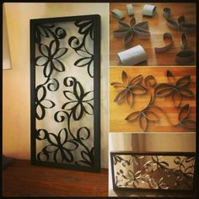schroederj2@leonschools.net 