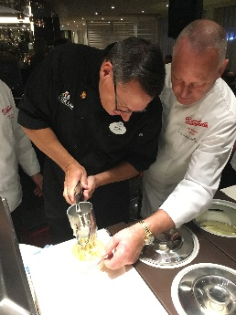
Spaghetti Ice Cream
This dish was invented by a German family. On a Rhine River Cruise a few years ago, the family was invited onboard our ship to show us their culinary creation. It was such fun. This is our lab for the week.
Active time -15 min. Equipment – ice cream scoop, butter knife, potato ricer or noodle extruder, blender (or something to mash strawberries with) , zester
Ingredients
2 scoops of vanilla ice cream per serving
1 C of strawberries frozen or fresh (washed and stemmed)
1-2 Ferraro Roche chocolate balls per serving
Square of white chocolate or slivered blanched almonds

- Put ricer in freezer for a few minutes to get it extra cold, and leave ice out of freezer for a few minutes to soften. If using frozen strawberries, leave them out to thaw.
- Using ricer or extruder, put 2 scoops of ice cream into whichever you are using, and squeeze/extrude onto serving dish or parchment on a baking sheet, do this as individual servings. Put ice cream noodle piles into the freezer.
- Using blender turn your strawberries into puree. You could just use a fork to mash really well.
- Using the zester, grate your chocolate into shavings. If you don’t have a zester, chope/mince finely. If you are using almonds instead, just chop finely so it looks like parmesan cheese.
- Plate – put frozen piles of noodle ice cream onto serving plate, spoon a bit of strawberry (marinera) onto noodles, unwrap and place your chocolate (meatballs) on top, then sprinkle with your while chocolate (parmesan).
- Voila – Spaghetti Ice Cream – Take a picture, email it to me. There is also a worksheet to fill out to get the credit. For a grade I need a picture of you while making the dish, a picture of the finished product and the worksheet form filled out and all 3 pieces emailed to me.

